**Interview Appointment Scheduler System**

2 different type of users: HR & Trainer

Both of them can:

1. Schedule an new interview by clicking button "New Interview", scheduler name should be the current login username and cannot be modified. Phone number will be the interview's phone. User can upload resume by clicking the "Upload" button, but this is not necessary.

*Sample screenshot attached.*

2. Update the appointment status to Pending/Canceled/Passed/Failed.

By modifying the status of an interview appointment, user should be able to see the updated meeting item in the corresponding tab page.

Sample page of tab "All Appointments" is shown as below, the grid is able to display 5 / 10 / 25 items per page as user's selection.

Clicking on column name should be able to toggle the form to sort by that column as:  
"By default" ->"Ascending" -> "Descending"

3. View / Upload / Download resume file by clicking on the button for each interview. New resume can always be uploaded, but user can only view / download it if it exists.   
Circle - resume available to view (Open in browser).  
Upper Arrow - Upload new resume file.  
Down Arrow - Download resume to local.

HR feature only:

1. "Upload" button on main page will only be available to HR user, which allow him to upload historical interview data from excel sheet. *Sample file attached.*

Use multi thread to upload the file. Define jobs for each tab of the excel sheet and use thread pool to complete them, make sure they works concurrently and the IDs should not have any conflict.

2. "Chart" tab on main page will only be available to HR user, which allow him to view data statistics in chart format, design and implement at least 2 charts as you want. *Sample page not provided.*

*eg.:*

*- Show interviews amount for each scheduler in pie chart.  
- Show pass rate of each scheduler in bar chart.  
- Show interview amount of: the company, each scheduler in line graph.*

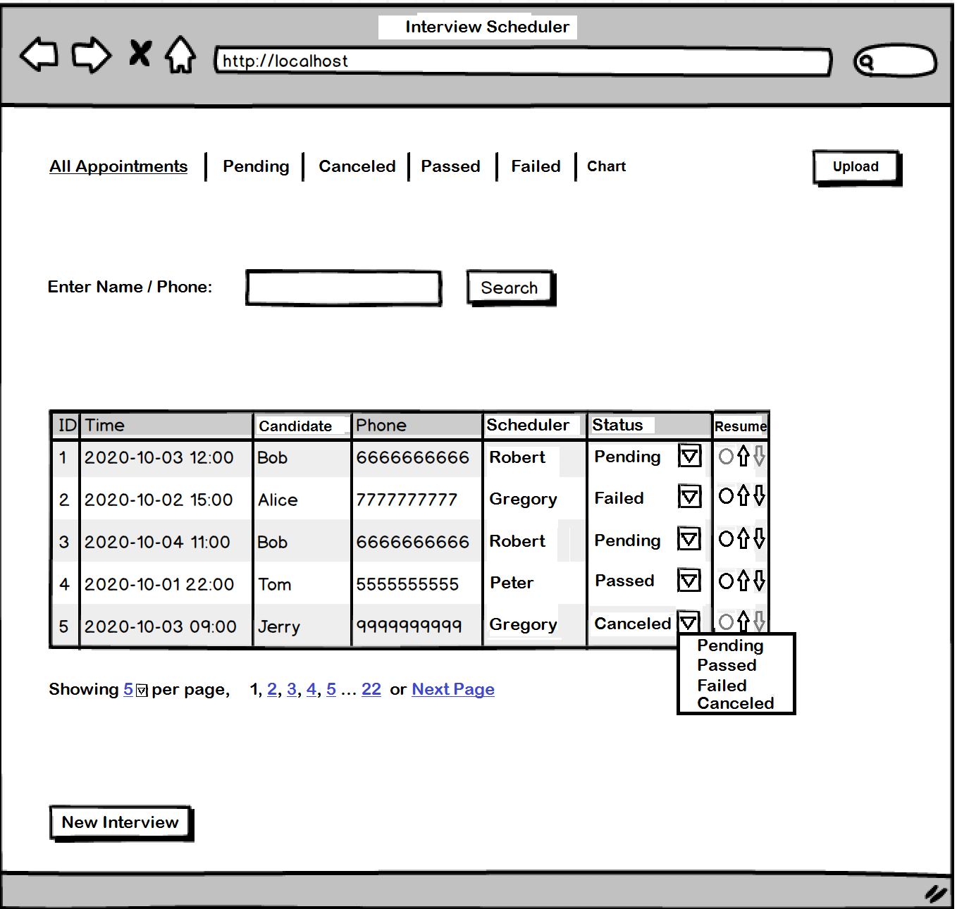

Once user click the "New Interview" button, or click any existing appointment in the grid, below window should pop up, with either empty ("New Interview" button clicked), or filled by existing information (existing appointment is clicked).

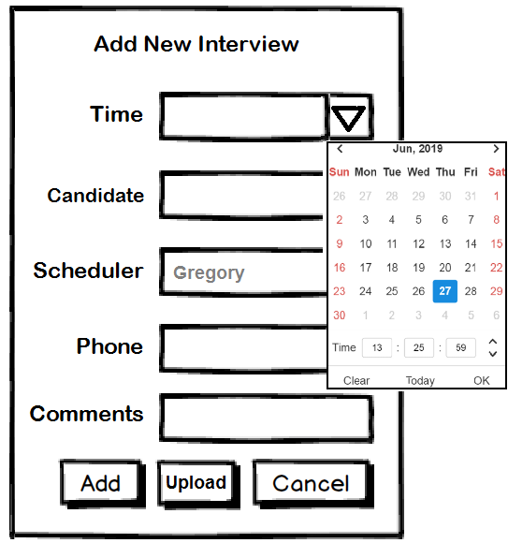

**Possibly Additional Feature:**

1. Add feature for HR to randomly select available trainer for interview. Consider below:

- Time availability of that trainer  
- Should fairly/unfairly(maybe choose more on those who has higher pass / fail rate) assign interview to each trainer.

2. For data merging, provide a feature to download all selected data from database into a CSV file, by input a SQL.(Maybe with a new button on main page for download)

3. Add profile picture tab for each incoming candidate, allow user to upload a picture for each candidate, but for bandwidth concern, only show thumbnail picture on each row when system loaded, unless user click on it then original picture shows up.

4. Since more and more data will be inserted into the system, so chart generation will become slower and slower. Can you resolve this issue by storing the chart information directly into a database view?